SIMATS ENGINEERING
ASSESSMENT TOOL 1

COURSE CODE: ITA04
COURSE NAME: STATISTICS WITH R PROGRAMMING

COURSE OUTCOME COVERED

CO2: Implement looping constructs, control structures, and recursive functions in R to solve computational problems with efficient program logic. (BL3, BL4)

Assessment Tool Weightage: 15%

QUESTIONS: 10 Total Marks: 100

ANNEXURE A

Coding Challenge

1. Smart Electricity Consumption Monitor
Real-time scenario: An electricity board monitors daily power consumption to identify high-energy usage.
Challenge: Write an R program that accepts electricity consumption in units for multiple households. Use a loop to process each household, calculate the bill using the tariff below, and identify households with unusually high consumption.
- First 100 units: ₹2 per unit
- Next 100 units: ₹3 per unit
- Units above 200: ₹5 per unit
- Consumption above 250 units: display a high-consumption alert.
- Use -1 to stop entering household data and break to terminate the loop.
- Use a function to calculate the bill.
Sample input: 80, 150, 280, 90, -1
Expected result: Display each household's units, bill amount, and high-consumption alert where applicable.
calculate_bill <- function(units) {
if (units <= 100) {
return(units * 2)
} else if (units <= 200) {
return(200 + (units - 100) * 3)
} else {
return(500 + (units - 200) * 5)
}
}
repeat {
units <- as.numeric(readline("Enter units (-1 to stop): "))
if (is.na(units)) {
print("Please enter a valid number")
next
}
if (units == -1) {
break
}
bill <- calculate_bill(units)
print(paste("Units consumed:", units))
print(paste("Bill amount: Rs.", bill))
if (units > 250) {
print("High consumption alert!")
}
}
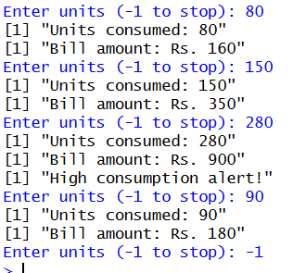
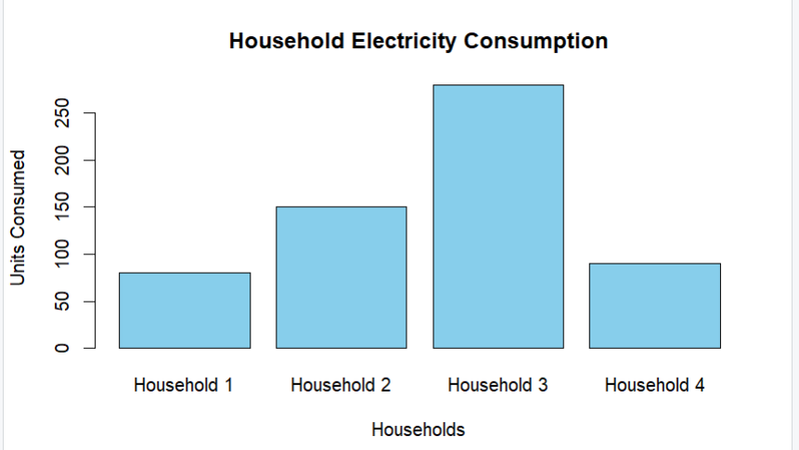

2. Student Attendance and Examination Eligibility
Real-time scenario: A college needs to identify students who meet the minimum attendance requirement for final examinations.
Challenge: Write an R program to process attendance records for multiple students.
- Accept each student's name, classes attended, and total classes conducted.
- Calculate the attendance percentage using a loop.
- Use if-else to classify students with at least 80% attendance as eligible and others as not eligible.
- Use next to skip records containing invalid attendance values.
- Display the students who are below the 80% threshold.
Sample data:
Student | Attended | Total
Arun | 85 | 100
Priya | 72 | 100
Kavin | 40 | 50
Expected result: Arun – Eligible (85%); Priya – Not eligible (72%); Kavin – Eligible (80%).
students <- c("Arun", "Priya", "Kavin")
attended <- c(85, 72, 40)
total <- c(100, 100, 50)
for (i in 1:length(students)) {
if (attended[i] < 0 || total[i] <= 0 || attended[i] > total[i]) {
next
}
percentage <- (attended[i] / total[i]) * 100
if (percentage >= 80) {
status <- "Eligible"
} else {
status <- "Not eligible"
}
cat(students[i], "-", status, "(", percentage, "%)\n")
if (percentage < 80) {
cat("Below 80% attendance:", students[i], "\n")
}
}
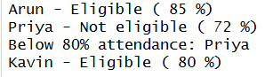
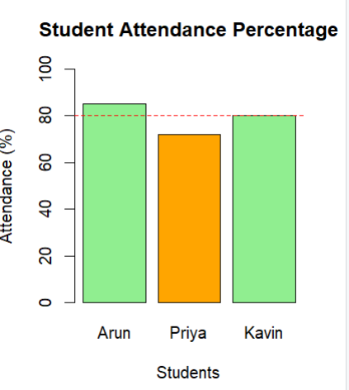

3. Hospital Patient Vital-Sign Monitoring
Real-time scenario: A hospital monitors patient readings and flags values that require clinical review.
Challenge: Write an R program to process a sequence of patient heart-rate readings.
- Use a while() loop to read or process readings until a sentinel value of -1 is entered.
- Flag readings below 60 or above 100 beats per minute for clinical review in an adult-monitoring example.
- Use if-else to classify readings as below the reference range, within the reference range, or above the reference range.
- Use break to stop processing when the sentinel value is entered.
- Count and display the total number of flagged readings.
Sample input: 72, 110, 58, 85, 105, -1
Expected result: Flag 110, 58, and 105; report 3 flagged readings.
Note: This is a programming exercise, not a clinical diagnostic rule. Interpretation depends on patient context and clinical guidance.
heart_rate <- c(72, 110, 58, 85, 105, -1)
i <- 1
flagged <- 0
while (TRUE) {
rate <- heart_rate[i]
if (rate == -1) {
break
}
if (rate < 60) {
cat(rate, "- Below reference range\n")
flagged <- flagged + 1
} else if (rate > 100) {
cat(rate, "- Above reference range\n")
flagged <- flagged + 1
} else {
cat(rate, "- Within reference range\n")
}
i <- i + 1
}
cat("Total flagged readings:", flagged, "\n")

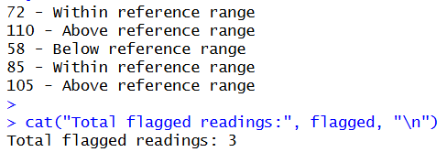
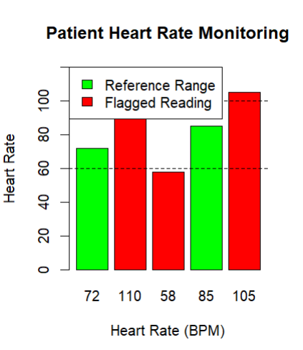

4. Delivery Route Distance Calculator
Real-time scenario: A delivery company calculates the total distance travelled by a vehicle across several route segments.
Challenge: Write an R program using a recursive function to calculate the total distance of a delivery route.
- Accept a vector of distances for individual route segments.
- Create a recursive function that adds each segment's distance to the remaining route distance.
- Define an appropriate base case to stop recursion.
- Reject negative distances.
- Compare the recursive result with the result obtained using R's sum() function.
Sample input: c(12, 8, 15, 10, 5)
Expected result: Total distance = 50 km using both approaches.
Analysis requirement: Explain how the base case prevents infinite recursion and discuss the limitations of recursion for very long routes.
total_distance <- function(distance) {
if (length(distance) == 0) {
return(0)
}
if (distance[1] < 0) {
stop("Negative distances are not allowed")
}
return(distance[1] + total_distance(distance[-1]))
}
distance <- c(12, 8, 15, 10, 5)
if (any(distance < 0)) {
print("Negative distances are not allowed")
} else {
recursive_total <- total_distance(distance)
normal_total <- sum(distance)
cat("Recursive total:", recursive_total, "km\n")
cat("Sum function total:", normal_total, "km\n")
}
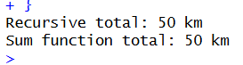
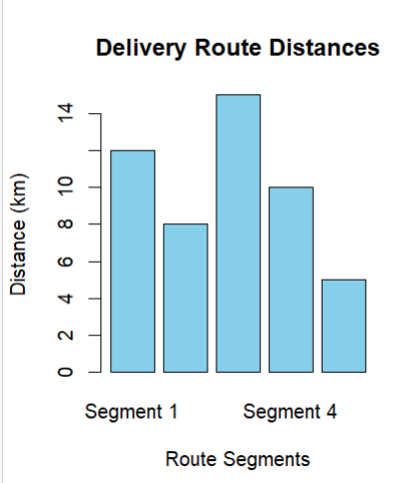

5. Banking System – Recursive Loan Balance Calculator
Real-time scenario: A financial application estimates the remaining loan balance after each monthly payment.
Challenge: Write an R program using a recursive function to calculate a loan balance over a specified number of months, assuming a fixed monthly interest rate and fixed monthly payment.
- Accept the initial loan amount, monthly interest rate, monthly payment, and number of months.
- Calculate the updated balance using: balance × (1 + monthly interest rate) − monthly payment.
- Use recursion to calculate the balance month by month.
- Stop when the specified number of months is reached or the loan is fully repaid.
- Detect cases where the payment does not exceed the monthly interest and explain why the loan may not be repaid.
Sample input: Initial balance = ₹10,000; monthly interest = 1%; monthly payment = ₹1,000; duration = 3 months.
Expected result:
Month | Remaining Balance
0 | ₹10,000.00
1 | ₹9,100.00
2 | ₹8,191.00
3 | ₹7,272.91
Analysis requirement: Explain the recursive base case and compare the recursive calculation with an iterative loop.
loan_balance <- function(balance, rate, payment, months) {
cat("Month", months, "- Remaining Balance: Rs.",
sprintf("%.2f", balance), "\n")
if (balance <= 0 || months == 0) {
return(max(0, balance))
}
interest <- balance * rate
if (payment <= interest) {
stop("Payment does not exceed monthly interest. Loan may not be repaid.")
}
new_balance <- balance * (1 + rate) - payment
if (new_balance < 0) {
new_balance <- 0
}
return(loan_balance(new_balance, rate, payment, months - 1))
}
initial_balance <- 10000
monthly_rate <- 0.01
monthly_payment <- 1000
duration <- 3
loan_balance(initial_balance, monthly_rate,
monthly_payment, duration)
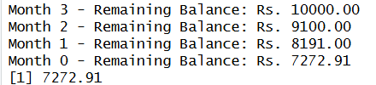
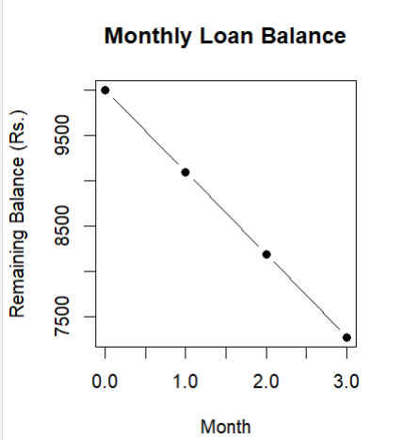

Code of Conduct:

I Varsha.M/1924260282 (Name / Reg No) certify that this submission is my original work and that I have adhered to the guidelines specified for this assessment.
I understand that any violation of academic integrity rules will result in disciplinary action.

Signature of the student: 

RUBRICS FOR CALCULATION:

Criteria | Weightage | Level 4 (Exemplary) | Level 3 (Proficient) | Level 2 (Developing) | Level 1 (Beginning)
Problem Understanding | 20% | Clearly understands problem constraints, edge cases, and competitive requirements | Understands problem with minor gaps in constraints | Partial understanding; misses key constraints | Misinterprets problem or constraints
Algorithm | 25% | Selects optimal algorithm with best time and space complexity for competitive constraints | Uses efficient algorithm with minor scope for improvement | Uses basic/inefficient approach | No clear algorithmic approach
Code Implementation | 20% | Writes correct, efficient, and clean code that passes all constraints | Code works with minor errors or inefficiencies | Partially correct code; fails for some cases | Code does not execute or gives incorrect results
Competitive Performance | 20% | Solves problem within time limits and handles large inputs effectively | Solves within acceptable time with minor delays | Struggles with time limits or larger inputs | Unable to solve within time constraints
Test Case Handling | 15% | Handles all test cases including edge and hidden cases | Handles most test cases | Misses important edge cases | Fails on multiple test cases

